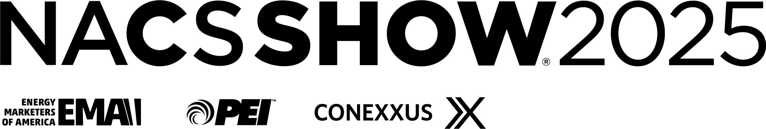

Primary and Secondary Company Badge Allotments

With each booth purchase, a set number of booth personnel badges is allotted based on square footage purchased (3 badges per 100 sq ft). The Primary must designate a quantity of their allotted badges for each Secondary company. In the chart below itemize how many badges should be provided to each company. All Secondary companies listed below must be NACS/PEI members or should have paid the $1,350 listing fee. Unpaid non-member Secondary companies cannot have badges noting their company names and must use badges from the Primary badge allotment.

Please note: The sum of the Primary and Secondary complimentary badges cannot exceed the total number of badges below.

Primary Exhibitor Booth Size: ____ = ___ total badges (3 per 100 sq. ft.)

Company Name Number of Badges
Primary Company:
Secondary Companies:

